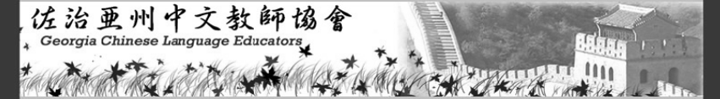



GCLE MEMBERSHIP FORM

会员申请表

Name *(English):* Click here to enter text. Name *(Chinese):*  Click here to enter text.

School/Organization Name: Click here to enter text.

School/Organization Official Web Site *(please print):* Click here to enter text.

Type of School/Organization  public  independent *(Double click on a box and then click “Checked” to add a checkmark.)*

Top of Form

*(Check all that apply)* K-8 K-12  College/University Other Click here to enter text.

Bottom of Form

Teacher/Professor  Administrator Other Click here to enter text.

Grade Level(s) You Teach: Grade(s): Click here to enter text.

Mailing Address:  Home  Work

Street: Click here to enter text.

City: Click here to enter text. Zip Code: Click here to enter text.

Top of Form

Office Telephone: Click here to enter text.

Bottom of Form

Home/Cell Phone: Click here to enter text.

Fax: Click here to enter text.

E-mail: Click here to enter text.

GCLE Office Use Only

Date received

Check#

Online

Comment _____________

Apply/Renew by Check

Please make check payable to:

Georgia Chinese Language Educators/GCLE

Mail check and filled form to

Gail Fang

West Hall High School

5500 McEver Rd.

Oakwood, Georgia 30566

*E-mail: gail.fang@hallco.org*

Apply online

Apply by check

Renew online

Renew by check

Bottom of Form

Top of Form

Bottom of Form

Individual Membership: $25.00

Institutional Membership: $100.00

*(up to five teachers)*